第七次上机实验#include <iostream> using namespace std; class matrixmul{private: double real; double imag;public: void output(); void initSet(double re,double im); matrixmul matrixMul(matrixmul Z1,matrixmul Z2);

}; matrixmul matrixmul::matrixMul(matrixmul Z1,matrixmul Z2){ double temp1,temp2,temp3; matrixmul result; temp1=Z1.real\*Z2.imag; temp2=Z1.imag\*Z2.real; temp3=(Z1.imag+Z1.real)\*(Z2.real-Z2.imag); result.real=temp1+temp3-temp2; result.imag=temp1+temp2; return result;} void matrixmul::initSet(double re,double im){ real=re; imag=im;} void matrixmul::output(){ if(imag>0) { cout<<real<<"+"<<imag<<"i"<<endl; } else if(imag==0) { cout<<real<<endl; } else if(imag<0) { cout<<real<<imag<<"i"<<endl; }} int main(){ matrixmul Z1,Z2,Z3,result; Z1.initSet(6,-2); Z2.initSet(8,-4); cout<<"第一个复数Z1为："<<endl; Z1.output(); cout<<"第二个复数Z2为："<<endl; Z2.output(); result=Z3.matrixMul(Z1,Z2); cout<<"两复数相乘结果的复数为："<<endl; result.output(); return 0;}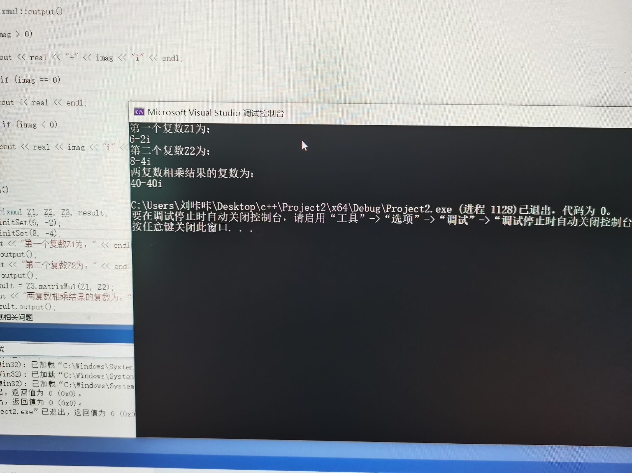

感想：最后一个上机实验，感想蛮多的，一来之后不用再上机了，心情愉悦，二来通过这几次上机，学到了很多，发现c++也很有意思，当努力去克服难题后，会有一丝小成就感。

Copyright@2021-2099 Liulei.All rights reserved